✅ What is Multi-Tasking?
Multi-Tasking means:
Executing multiple tasks at the same time (or appearing to run at the same time).
A task = a piece of work.
Example:
- Listening to music
- Writing Java code
- Downloading a file
- Watching YouTube
Your Operating System (OS) manages all these tasks and gives CPU time to each one.

✅ Why Multi-Tasking is Needed?
Main goal:
Use CPU time effectively and improve system performance.
If one task is waiting (like waiting for network or file I/O), CPU should not sit idle.
It should execute another task.
This:
- Reduces waiting time
- Improves response time
- Improves overall performance

✅ Types of Multi-Tasking
There are 2 types:
- Process Based Multi-Tasking
- Thread Based Multi-Tasking

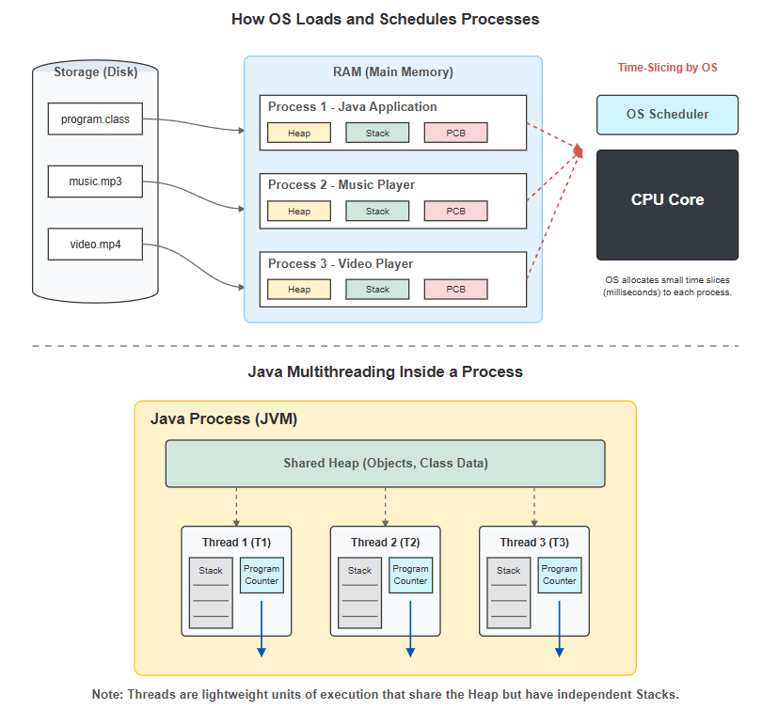

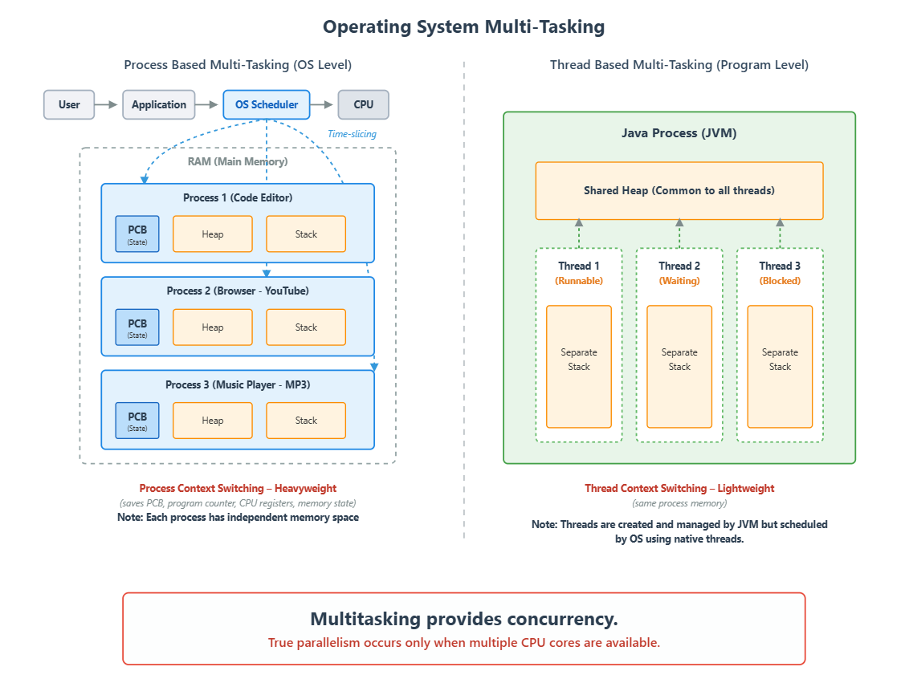

🔵 LEFT SIDE — Process Based Multi-Tasking (OS Level)
This part explains how operating system runs multiple applications.

1️⃣ Flow at Top
User → Application → OS Scheduler → CPU
What Happens Here?
- User opens applications (Editor, Browser, Music Player).
- Each application becomes a Process.
- OS Scheduler decides:
  - Which process gets CPU
  - For how much time
- CPU executes that process.
This is called:
Time Slicing
CPU gives small time slices to each process very fast.
So it looks like everything runs simultaneously.
But actually, CPU switches very quickly.

2️⃣ RAM (Main Memory)
Inside RAM you see:
- Process 1 (Code Editor)
- Process 2 (Browser – YouTube)
- Process 3 (Music Player – MP3)
Each process contains:
- PCB (Process Control Block)
- Heap
- Stack

📦 PCB (Process Control Block)
PCB stores:
- Process state
- Program counter
- CPU registers
- Scheduling info
When OS switches from one process to another:
It saves current process state in PCB.

🧱 Heap (Per Process)
- Stores objects
- Dynamic memory
- Shared only inside that process
Each process has separate heap.
No sharing between processes.

📌 Stack (Per Process)
- Stores method calls
- Local variables
- Execution flow
Each process has its own stack.

3️⃣ Process Context Switching (Heavyweight)
At bottom you wrote:
Process Context Switching – Heavyweight
Why Heavyweight?
Because OS must save and load:
- PCB
- CPU registers
- Program counter
- Memory state
This takes more time.
Also:
Processes have separate memory spaces.
Switching is expensive.

🟢 RIGHT SIDE — Thread Based Multi-Tasking (Program Level)
Now we move inside a single Java program.
Instead of multiple programs, we now divide one program into multiple tasks.

1️⃣ Java Process (JVM)
This entire green box is:
One Java process running inside OS.
Inside it:
- Shared Heap
- Multiple Threads

2️⃣ Shared Heap (Common for All Threads)
All threads share:
- Objects
- Instance variables
- Static variables
That means:
If Thread 1 modifies object,
Thread 2 can see it.
This is powerful — but dangerous.
This leads to:
- Race condition
- Synchronization need

3️⃣ Threads
You showed:
- Thread 1 (Runnable)
- Thread 2 (Waiting)
- Thread 3 (Blocked)
Each thread has:
- Separate Stack

📌 Thread Stack Contains
- Method calls
- Local variables
- Execution flow
So:
Threads share heap
But do NOT share stack

4️⃣ Thread Context Switching (Lightweight)
Why Lightweight?
Because:
- Same process memory
- Same heap
- Only stack & registers switch
No full memory swap required.
So switching is faster.

5️⃣ Important Line
“Threads are created and managed by JVM but scheduled by OS using native threads.”
This means:
- You create threads in Java
- JVM maps them to OS native threads
- OS scheduler gives CPU time
Modern JVM does NOT use green threads.
It uses native OS threads.

🔴 Bottom Statement — Very Important
“Multitasking provides concurrency.
True parallelism occurs only when multiple CPU cores are available.”
Let’s understand this deeply.

🧠 Concurrency
One CPU core
Switching between tasks very fast
It looks simultaneous
But actually time-shared.

⚡ Parallelism
Multiple CPU cores
Process 1 on Core 1
Process 2 on Core 2
Thread 3 on Core 3
Now truly running at same time.

🎯 Final Comparison (From Diagram)
Feature | Process | Thread
Memory | Separate | Shared Heap
Stack | Separate | Separate
Context Switch | Heavyweight | Lightweight
Managed By | OS | JVM + OS
Best Level | OS level | Program level

🏁 Final Understanding
Process based multitasking:
- Multiple independent applications
- Safe and isolated
- Heavy switching
Thread based multitasking:
- Multiple tasks inside same program
- Faster
- Shares memory
- Needs synchronization

In process-based multitasking, multiple independent processes are scheduled by the OS and run concurrently. They run truly in parallel only if multiple CPU cores are available.

In thread-based multitasking, multiple threads inside one process are scheduled (by OS via JVM) and run concurrently. They run truly in parallel only when multiple CPU cores are available.

What is a Thread?
A Thread is a separate flow of execution inside a program.
👉 Think of a thread as a worker doing a job.
If a program has multiple workers doing different jobs at the same time, it is called multithreading.

Single Thread Programming
If there is only one flow of execution, it is called:
Single-threaded programming
Example:
- First task completes
- Then second task starts
- No parallel execution
Only one worker is doing everything.

Multithreading
If multiple flows of execution run simultaneously, it is called:
Multithreading
- Each thread performs a separate task
- Threads share the same process memory
- Execution order is not guaranteed

Important Points About Threads
✔ Every thread has its own:
- Program counter
- Stack memory
- Execution path
✔ All threads share:
- Heap memory
- Method area
- Objects
✔ Thread execution is controlled by:
- Thread Scheduler (part of JVM)
- Scheduler decides which thread runs and when
- Scheduling algorithm is not exposed to developers
- Output order may change every time

Life Cycle of a Thread
- New – Thread object created
- Runnable – After calling start()
- Running – Scheduler selects it
- Blocked/Waiting – Waiting for resource
- Terminated – Execution finished

Ways to Create a Thread in Java
There are 2 ways:
- Extending Thread class
- Implementing Runnable interface
🔹 PART 1: Creating Thread by Extending Thread Class

🔵 Step 1: Understand the Design
When you extend Thread class:
- Your class becomes a Thread.
- You override run() method.
- run() contains the job of the thread.
- You call start() to begin execution.
Important idea:
start() creates a new thread.
run() defines what that thread should do.

🔵 Step 2: Create a Custom Thread Class
class MyThread extends Thread {
@Override
public void run() {
// This code is executed by child thread
for (int i = 1; i <= 5; i++) {
System.out.println(
"Child Thread - Count: " + i +
" - Executed by: " + Thread.currentThread().getName()
);
}
}
}
Important Concepts Here
✔ extends Thread → Our class becomes a thread
✔ @Override run() → Defines the job
✔ Thread.currentThread().getName() → Tells which thread is running

🔵 Step 3: Create Main Class and Start Thread
public class ThreadDemo {
public static void main(String[] args) {
System.out.println("Main method started");
// 1️⃣ Thread object creation (NEW state)
MyThread t = new MyThread();
// 2️⃣ Starting thread (moves to RUNNABLE state)
t.start();
// 3️⃣ Main thread job
for (int i = 1; i <= 5; i++) {
System.out.println(
"Main Thread - Count: " + i +
" - Executed by: " + Thread.currentThread().getName()
);
}
System.out.println("Main method ended");
}
}

🔵 What Happens Step-by-Step Internally?
When you run:
java ThreadDemo
Step 1: JVM Creates Main Thread
- JVM loads class
- Finds main() method
- Creates Main Thread
- Starts executing main()

Step 2: Thread Object Creation
MyThread t = new MyThread();
- Thread object is created
- Thread state = NEW
- No separate thread yet

Step 3: Calling start()
t.start();
Internally JVM does:
- Registers thread with Thread Scheduler
- Allocates stack memory
- Moves thread to RUNNABLE state
- Scheduler decides when to run
- JVM internally calls:
run();
Now we have:
- Main Thread
- Child Thread
Both run independently.

🔵 Why We Must Not Call run() Directly?
If we do:
t.run();
- No new thread created
- It behaves like normal method call
- Only main thread executes
So always use:
t.start();

🔵 Limitation of Extending Thread
Java does not support multiple inheritance.
If you extend Thread:
class MyThread extends Thread
You cannot extend another class.
That is a design limitation.

🔹 PART 2: Creating Thread by Implementing Runnable
This is the recommended way in real-time projects.

🔵 Step 1: Understand the Design
In this approach:
- Your class defines the task only.
- Thread class handles thread creation.
- Better separation of responsibility.
Runnable = Task
Thread = Worker

🔵 Step 2: Create Runnable Class
class MyRunnable implements Runnable {
@Override
public void run() {
// This code is executed by child thread
for (int i = 1; i <= 5; i++) {
System.out.println(
"Runnable Thread - Count: " + i +
" - Executed by: " + Thread.currentThread().getName()
);
}
}
}
Here:
✔ implements Runnable
✔ Must override run()
✔ This class is NOT a thread
✔ It is only a task

🔵 Step 3: Pass Runnable to Thread
public class RunnableDemo {
public static void main(String[] args) {
System.out.println("Main method started");
// 1️⃣ Create Runnable object
MyRunnable r = new MyRunnable();
// 2️⃣ Pass Runnable to Thread constructor
Thread t = new Thread(r);
// 3️⃣ Start the thread
t.start();
// 4️⃣ Main thread work
for (int i = 1; i <= 5; i++) {
System.out.println(
"Main Thread - Count: " + i +
" - Executed by: " + Thread.currentThread().getName()
);
}
System.out.println("Main method ended");
}
}

🔵 What Happens Internally?
When you call:
Thread t = new Thread(r);
Thread constructor stores Runnable object inside it.
Internally Thread class works similar to:
public void run() {
if (target != null) {
target.run();
}
}
Where target is your Runnable object.
So when you call:
t.start();
JVM:
- Creates new thread
- Registers with scheduler
- Calls Thread class run()
- That internally calls r.run()
So your Runnable logic runs inside new thread.

🔥 Why Runnable is Better?
✔ You can extend another class
✔ Clean separation of logic and execution
✔ Used in Executor framework
✔ Used in real-time backend systems
✔ More flexible

🔵 Thread Life Cycle in Both Cases
- NEW → Object created
- RUNNABLE → start() called
- RUNNING → Scheduler selects
- BLOCKED / WAITING (if needed)
- TERMINATED → run() completed

🔥 Final Comparison
Feature | Extending Thread | Implementing Runnable
Can extend another class? | No | Yes
Task and Thread separated? | No | Yes
Recommended in real projects? | Less | Yes
Used in Executor framework? | No | Yes

🎯 Final Understanding
Both ways create threads.
But:
Extending Thread = Simple but limited
Implementing Runnable = Professional and scalable approach

